|  |
| --- |
| **OXFORD INTERNATIONAL SCHOOL IQBAL CAMPUS**  **Preliminary testing or trial 2024**  **Name: _____________ Grade: VII Subject: Mathematics. /50** |

**Q1 (a): Multiple Choice Questions. /10**

1. 6x = 60
2. 6 b. 1 c. -5 d. 25
3. Gradient =

$\frac{vertical change }{horizontal change}$ ______
4. b. $\frac{rise }{run}$ c. both a and b d. axis
5. _______ is a measure of how steep a slope is.
6. Horizontal b. Vertical c. both d. Gradient
7. Sin A = $\frac{opposite }{hypotenouse}$ = _____
8. Sin b. $\frac{perpendicular}{base}$ c. $\frac{perpendicualr}{hypotenouse }$ d. both a and b
9. Sin A = $\frac{opposite}{adjacent}$ = _____
10. both b and c b. perpendicular c. . $\frac{perpendicular}{base}$ d. finite
11. A pentagon has ______ sides.
12. 5 b. 4 c. 3 d. 1
13. In a ________, the apex is the vertex at the "top" (opposite the base)
14. Sphere b. Pyramid c. Rectangle d. Triangle
15. Total surface area of Pyramid = ___________
16. Total volume b. total area of all faces c. both a and b d. sphere
17. A shape or an object has _________ if it can be divided into two identical pieces.
18. Symmetry b. area c. mirror d. lines
19. ∈ is a symbol which means _______. If b ∈ B, it shows that b is the element of B.
20. Not belongs to b. 'belongs to' c. U d. $∩$

**Q1 (b): Fill in the blanks. /5**

1. The formula of Mean = _____
2. Volume of Cylinder = ______
3. Volume of Pyramid = ______
4. Y-axis is always be _______
5. Volume of Sphere = _______

**Q2: Given that the equation of the line representing each of the following linear graphs is in the form Y=mx+c, find the gradient m and state the y-intercepts. /5**

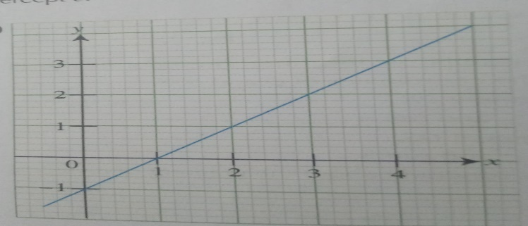 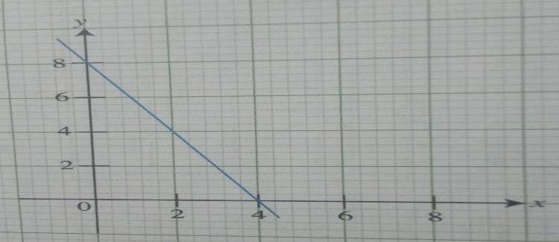

**Q3: Use calculator to evaluate each of the following. /3 a. $\frac{5 tan {61.4}^{o}}{2cos{10.3}^{0}}$**

**Q4: Find the value of unknown in each of the following right-angled triangle. /3**

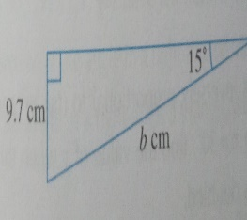

**Q5: OABCDEF is hexagonal Pyramid with a base area of 23 cm2 and a height of 6cm find the Pyramid.** **/5**

1. 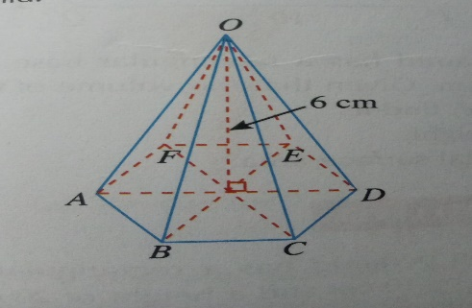

**Q6. A cone has a height of 14cm and a volume of 132cm3. Find the radius of the circular base. (Take π to be $\frac{22}{7}$) /5**

**Q7. How many lines of symmetry are there each of the following shapes? /4**

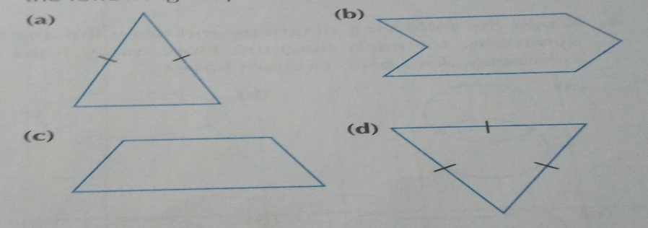

**Q8. List the element of the following sets. /5**

1. **{vowels in the word “MATHEMATICS”}**
2. **{The seven colors of rainbow}**
3. **{Multiples of 9 which are less then 50)**
4. **{Colors in your school flag}**
5. **{Even numbers which are between 10 and 23}**

**Q9. The number of days the students in a class were absent from school in a term was**

**recorded. /5**

|  |  |  |  |  |  |  |  |  |
| --- | --- | --- | --- | --- | --- | --- | --- | --- |
| **Number of days absent.** | **0** | **1** | **2** | **3** | **4** | **5** | **6** | **9** |
| **Number of students** | **23** | **4** | **5** | **2** | **2** | **1** | **2** | **1** |

**Find the mean number of days of absence.**